## Team Project

**Course: Cascading Style Sheets (CSS)**

**Deadline: June 29th, 2020**

|  |
| --- |
| ***Team Members*** |

Zongqi Lyu

Zhaohai Meng

Yaguang Liu

Shijun Wang

|  |
| --- |
| ***Project Objective*** |

To build a comprehensive website with various functions for a restaurant.

|  |
| --- |
| ***Flowchart*** |

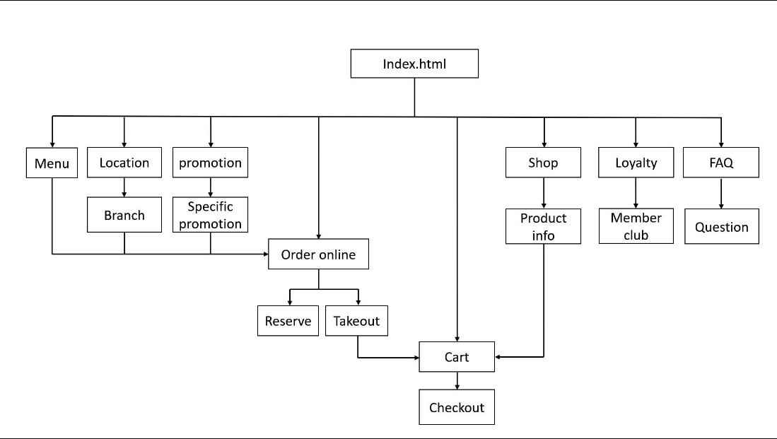

|  |
| --- |
| ***To-Do-List*** |

Minimum 2 pages per person

One page containing a form

Login-registration-mdl.html

Subscription section in Footer

locations.html

Appropriate meta tags

One page utilizing tables effectively

HOURS and CONTACT sections of the footer part use the tables.

One animated image

Logo, banner background images and menu images in index.html are animated.

Order and Shop page all pics

Promotions page all pics

One thumbnail image

Order page all pics

Promotions page all pics

One e-mail link

Contact section in Footer

One link outside your site

LINK of footer part and media list link to the outside websites.

The Map in the locations page links to the outside website.

One page utilizing different types of list

Faq.html

Footer

|  |
| --- |
| ***Assignment Questions*** |

1. What is the type of the Web site (portal, new, informational, business/marketing, educational, entertainment, social network, blog, wiki, or personal Web site)?

Our Web site is to show the food and the services provided in Lorem Steakhouse. This is a business/marketing Web site.

1. What is the purpose of the site?

The purpose of the site is to advertise the restaurant to website visitors – including the restaurant’s existing customers and potential customers, increase the business awareness and provide various online services as an effective supplementary of the physical entities.

1. What are the objectives of the site?

The object of our project: since we are a restaurant website, so the major object is to advertise our restaurant food and service, as well as the location of our restaurant. Also, the website can help the restaurant to process online order.

1. What do you want the Web site to accomplish? What results do you want to see?

The Web site will show the visitors the food and the services provided in our restaurant. We want more and more Web site visitors to be inspired to get to know us, and come to our restaurant or order online often, then eventually become our loyal customers.

1. What information do you need?

We need to know: 1) the basic information of the restaurant, such as name, address, locations, histories, etc.; 2) the products and services which are supposed to be shown to website visitors; 3) how the visitors could purchase on the website; 4) the way to integrate online services and physical entities.

1. What opportunity, problem, or issue is your site addressing?

Our website can help those customers who cannot or not willing to leave their home to order food. Also, the website can help the customer know more about our food and service, in order to bring more customer to our business.

1. Who is the intended audience? Will the audience consist of potential customers, current customers, or employees of a particular company or industry?

The Web site doesn’t target a particular company or industry. The intended audience should be various people. Some of them are the potential customers, some of them are our current customers. They can get the information or the service that they want through our Web site.

1. List the working title of each page on your Web site.

“Lorem Steakhouse” (index page);

“Menu | Lorem Steakhouse”, “Locations | Lorem Steakhouse”, “Promotions | Lorem Steakhouse”, “Order | Lorem Steakhouse”, “Shop | Lorem Steakhouse”, “Member Club | Lorem Steakhouse”, “FAQ | Lorem Steakhouse”, “Account | Lorem Steakhouse” – for login and registration, subscription completed, registration completed.

1. List where you will obtain the content for the web pages you listed above.

We can find some similar website and reference some text from them such as 4 rivers smoke house and Boston pizza, also, we can find pictures from some website as “unsplash”. But the major content of the website will be produced by ourselves.